Lesson Plan
Handouts

Vocabulary
Pedestrian
Roadway
Crosswalk
Intersection
Sidewalk
Street corner
Vehicle
Walking School Bus

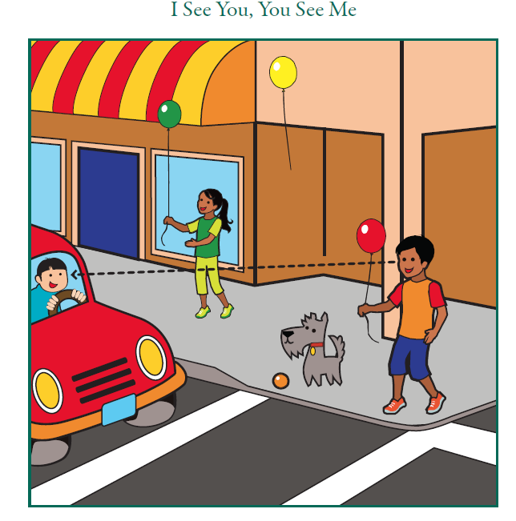

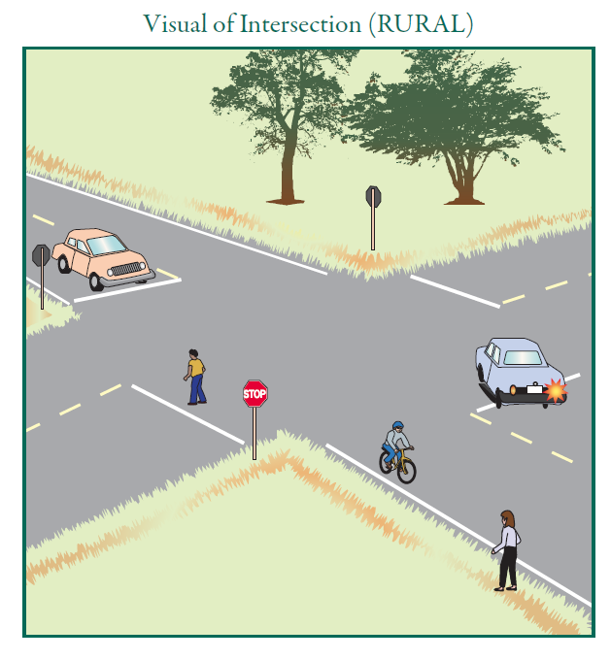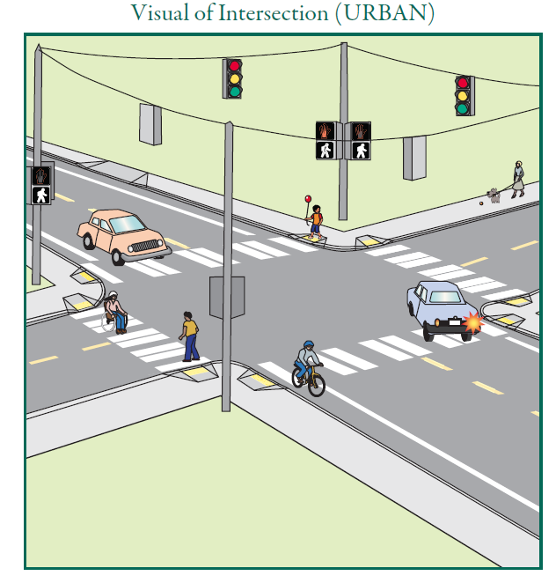

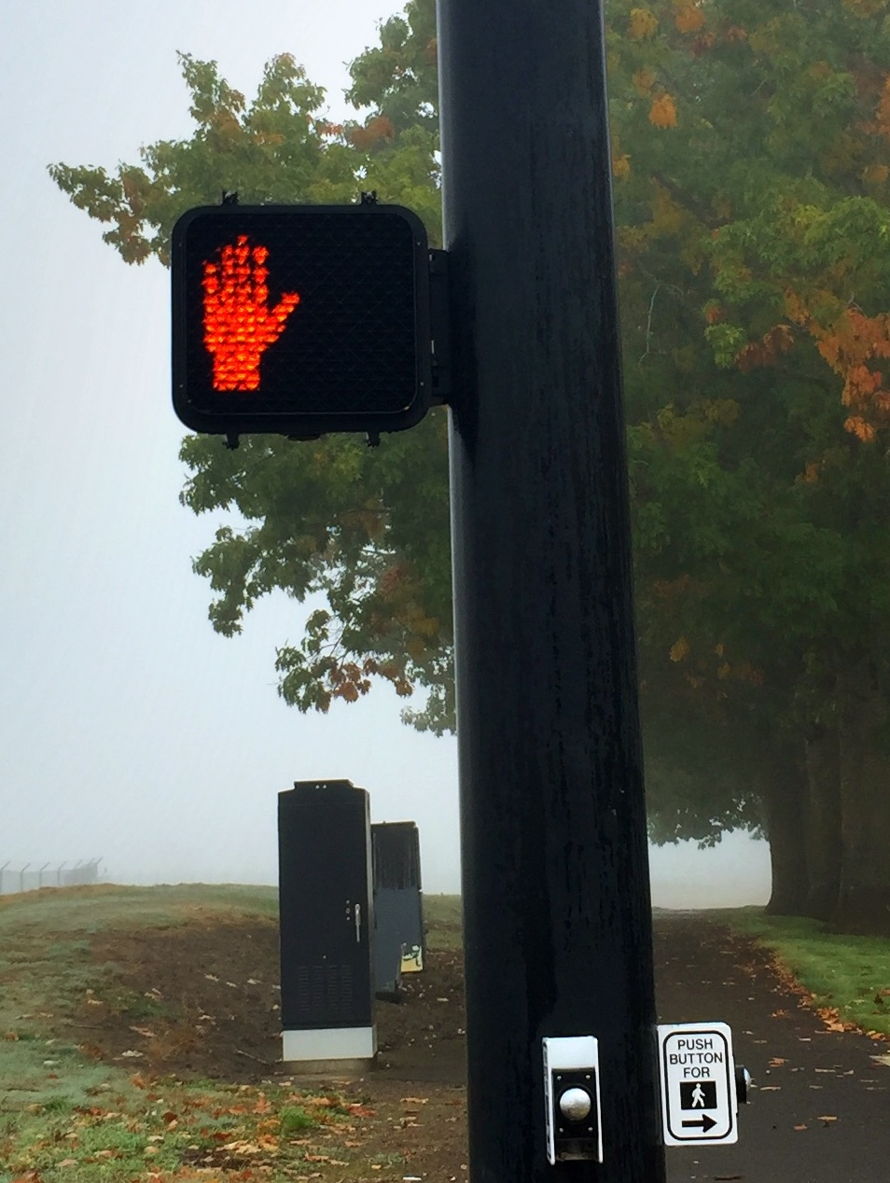
Don’t Walk
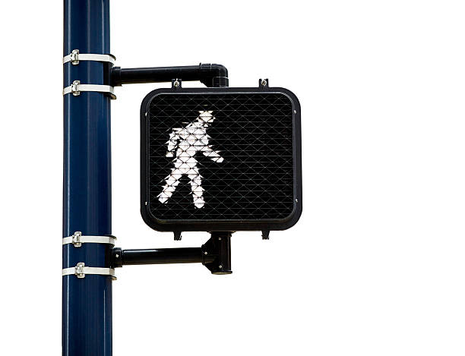

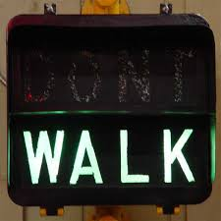
Hazards
• The clue is a driveway; the hazards are the cars driving in and backing out putting pedestrians in danger
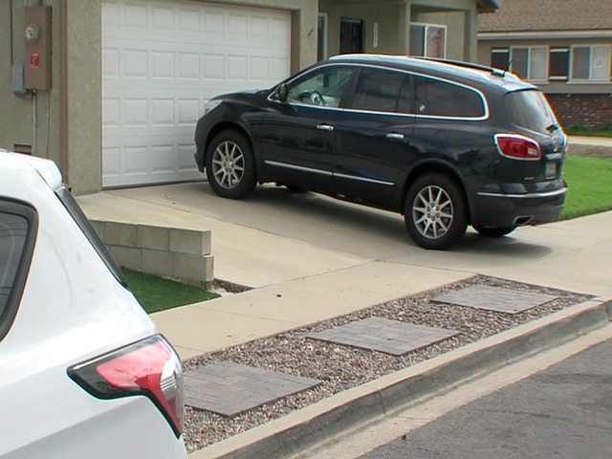
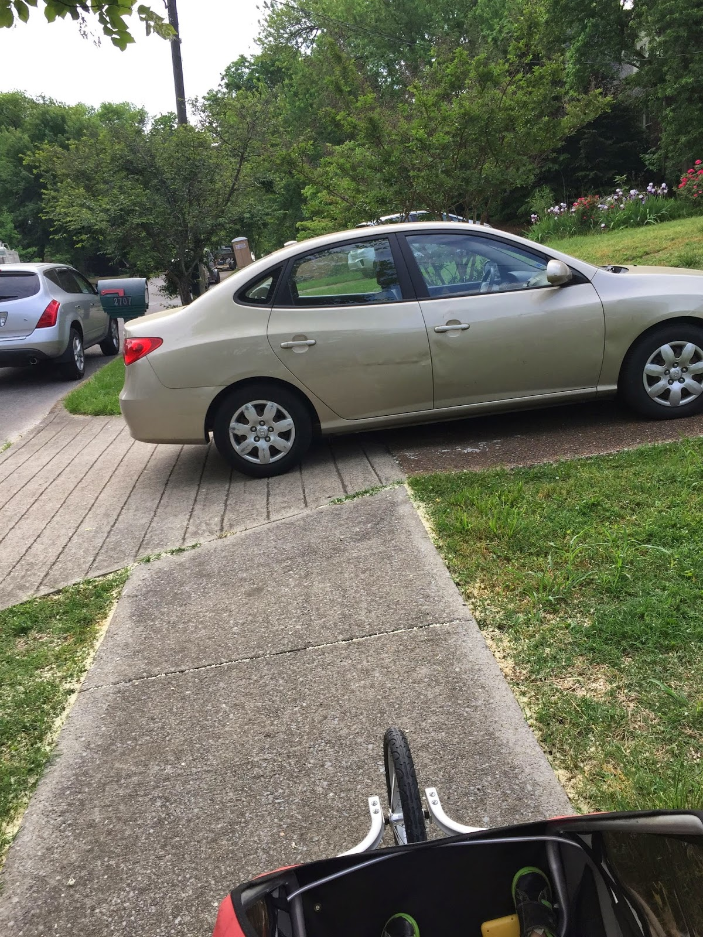

• The clue is a high hedge or overgrown plants; the hazard is that these plants can block the view of the driver from seeing a pedestrian
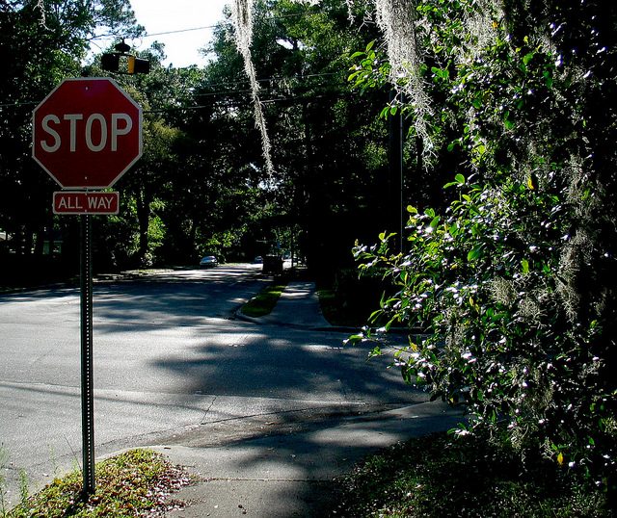

• The clue is uneven sidewalk, crumbling curb; crumbling sidewalk; the hazard is an uneven or broken sidewalk may cause a pedestrian to trip and fall
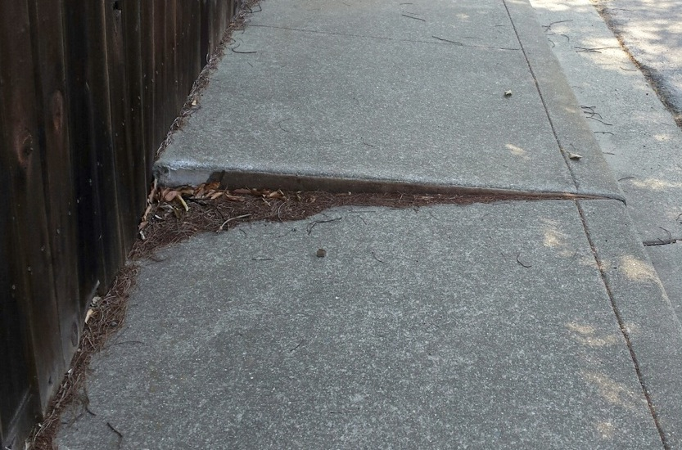

• The clue is parked cars; the hazard is a driver may not see a pedestrian stepping out between parked cars

